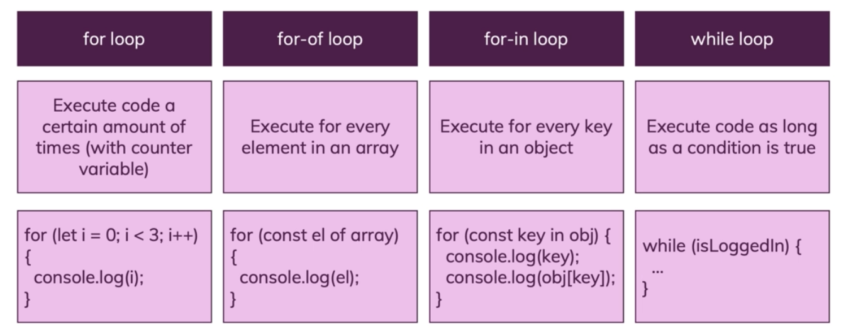

**Difference between for-of and for-in loop:**

1. **for-in** ES6 feature, it executes on the key of **object**.
2. **for-of** executes on the element of **object**

